26-08-2026

EXPERIMENT 29 – MEDICAL DIAGNOSIS

AIM
To write a Prolog program to diagnose a disease based on symptoms.

ALGORITHM
- Start the program.
- Define symptoms for different persons.
- Define rules connecting symptoms with diseases.
- Query the person for diagnosis.
- Display the disease matching the symptoms.

PROGRAM
symptom(aseem, fever).
symptom(aseem, cough).
symptom(aseem, body_pain).

symptom(arun, fever).
symptom(arun, headache).
symptom(arun, cold).

disease(Person, flu) :-
symptom(Person, fever),
symptom(Person, cough),
symptom(Person, body_pain).

disease(Person, common_cold) :-
symptom(Person, cold),
symptom(Person, headache),
symptom(Person, fever).

OUTPUT

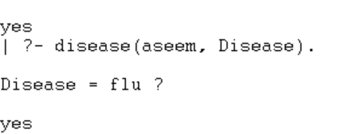

RESULT
Thus, the Prolog program was successfully executed to perform rule-based medical diagnosis.

